Configure the environment and compile/run cuGMEC

Environment：
- CUDA (major version number at least 12): https://developer.nvidia.com/cuda-toolkit
- NCCL: https://developer.nvidia.com/nccl
- cuDSS: https://docs.nvidia.com/cuda/cudss/
- MPI: https://www.intel.cn/content/www/cn/zh/developer/tools/oneapi/mpi-library-download.html
We recommend you update all above to the latest version and we give you an example of these installations below.

CUDA:
- Download CUDA Toolkit Installer according to your linux version and install according to the official documentation.
- Setting the environment variables with the following command:
vim ~/.bashrc
export PATH=/usr/local/cuda-12.6/bin${PATH:+:${PATH}}
export LD_LIBRARY_PATH=/usr/local/cuda-12.6/lib64${LD_LIBRARY_PATH:+:${LD_LIBRARY_PATH}}
source ~/.bashrc
- The command: nvcc --version can show the CUDA version if the installation is successful.

NCCL:
- Download a local installer and copy it to your cluster.
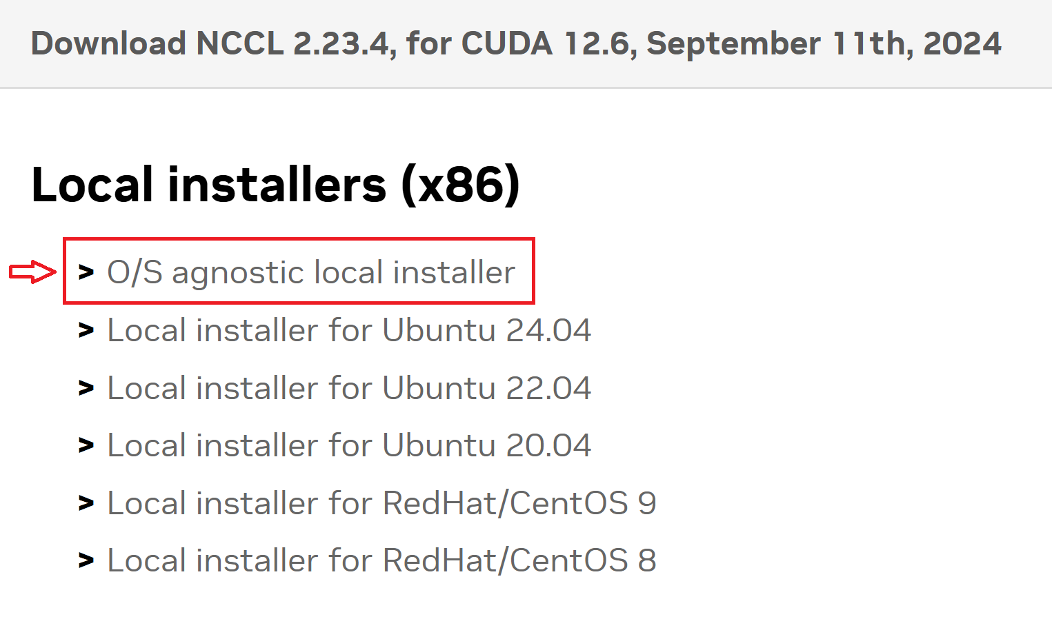
- Extract the download package to a directory and rename the ouput folder with the following commands:
tar xvf nccl_2.23.4-1+cuda12.6_x86_64.txz
mv nccl_2.23.4-1+cuda12.6_x86_64 nccl
- Then you have /include and /lib in /nccl, which will be used during compiling.

cuDSS:
- Download a local installer and copy it to your cluster or use wget command.
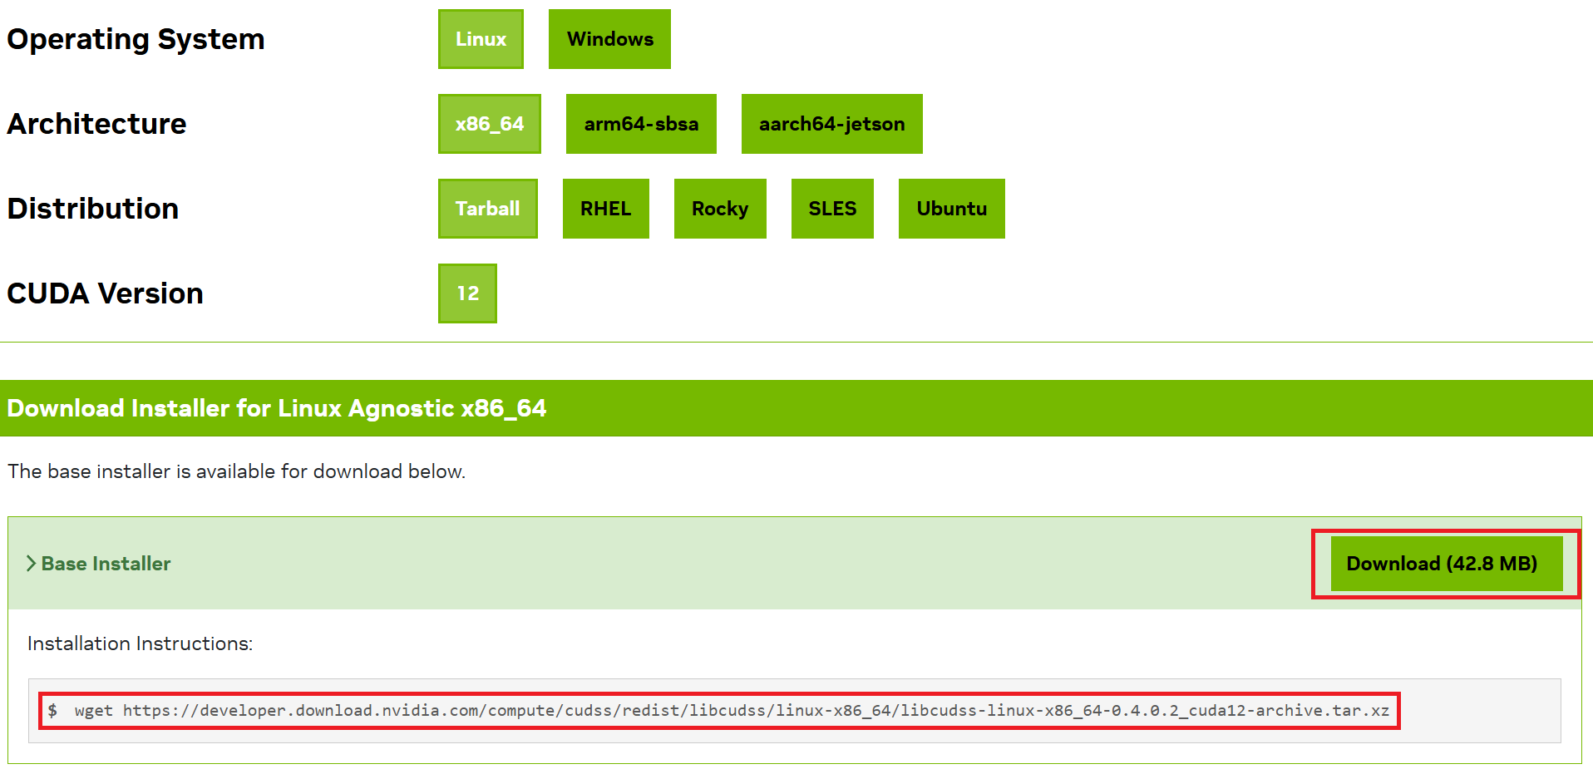
- Extract the download package to a directory and rename the ouput folder with the following commands:
tar xvf libcudss-linux-x86_64-0.4.0.2_cuda12-archive.tar.xz
mv libcudss-linux-x86_64-0.4.0.2_cuda12-archive cudss
- Then you have /include and /lib in /cudss, which will be used during compiling.
MPI:
- Download .sh file on the website we provide, with Operating System: Linux, Installer Type: Offline Installer. Copy it to your cluster.
- Use the following command to start installation and you can specify the directory when installing.
sh intel-mpi-2021.14.1.7_offline.sh
- Then you have setvars.sh in /intel/oneapi, which will be used during compiling.

Parameters Setting:
- You have to set the following parameters from lines 1 to 200 in the kernel.cu. Do not modify all parameters not mentioned in these tables.

/*---------------------Data Type and File Address---------------------*/
Parameter | Possible Value | Description | Example
dataType | float, double | specify the data type used in program running | using dataType = float;
MHDCollocated | string | the address of collocated grid equilibrium file | const std::string MHDCollocated = "../MHDCollocated.bin";
MHDStaggered |  | the address of staggered grid equilibrium file | const std::string MHDStaggered = "../MHDStaggered.bin";
MHDPerturbation |  | the address of collocated grid perturbation file | const std::string MHDPerturbation = "../MHDPerturbation.bin";

/*------------------------------Scale Setting------------------------------*/
Parameter | Possible Value | Description | Example
hostNums | nonnegative integer | how many processes in MPI | const int hostNums = 4;
devNums |  | how many GPUs are controlled in each process | const int devNums = 8;
gridNx |  | grid points in the radial direction | const int gridNx = 256;
gridNy |  | grid points in the field aligned direction | const int gridNy = 64;
gridNz |  | grid points in the toroidal direction | const int gridNz = 640;
ppcNums |  | particle numbers per cell for each species | const int ppcNums = 64;
tubes |  | 1 / tubes toroidal space will be simulated  multiple toroidal mode numbers will be simulated, including N*tubes  leftN <= N <= rightN | const int tubes = 1;
leftN |  |  | const int leftN = 0;
rightN |  |  | const int rightN = 30;
leftM |  | the range of poloidal mode numbers M of the N = 0 mode component  leftM <= M <= rightM | const int leftM = 0;
rightM |  |  | const int rightM = 2;

/*-------------------------Normalization Setting-------------------------*/
Parameter | Value Type | Description | Example
B0 | nonnegative floating-point | magnetic field used for normalization according to equilibtium input | const double B0 = 4.9831025;
L0 |  | length used for normalization according to equilibtium input | const double L0 = 6.5946372;
VA0 |  | velocity used for normalization according to equilibtium input | const double VA0 = 8.9921365e+06;
CHI0 |  | poloidal flux at innner boundary according to equilibtium input | const double CHI0 = 0.4556322;
CHI1 |  | poloidal flux at outer boundary according to equilibtium input | const double CHI1 = 8.1450858;

/*-----------------------------MHD Setting-----------------------------*/
Parameter | Value Type | Description | Example
ifStaggered | trueType, falseType | whether to simulate using staggered grid | using ifStaggered = trueType;
ifNonlinear |  | whether the MHD equations include nonlinear terms | using ifNonlinear = trueType;
ifEparallel |  | whether the hybrid model includes parallel electric field | using ifEparallel = trueType;
ifFLRMHD |  | whether the poisson equation includes FLR effect of thermal ions | using ifFLRMHD = trueType;
ifNablaPerp2F |  | whether to apply dissipation $∇_{⊥}^{2}$ to F (w, A, dNe, dTe, dPi, dPa, dPb) | using ifNablaPerp2w = falseType;
ifNablaPara4F |  | whether to apply hyperviscosity $∇_{||}^{4}$ to F | using ifNablaPara4w = falseType;
perp2F | nonnegative floating-point | normalized $∇_{⊥}^{2}$ coefficient for F  when F = A, it means normalized parallel resistive | const dataType perp2F = 0.0;
para4F |  | normalized $∇_{||}^{4}$ coefficient for F | const dataType para4F = 0.0;

/*------------------------------PIC Setting------------------------------*/
Parameter | Value Type | Description | Example
randomState | curandStateXORWOW_t  curandStateMRG32k3a_t  curandStatePhilox4_32_10_t | PRNG used for generating uniformly distributed 3d coordinates  these coordinates will be used in slowing down process | using randomState = curandStateXORWOW_t;
randMax | nonnegative integer | the numbers of uniformly distributed 3d coordinates in each GPU | const unsigned int randMax = 1 << 24;
ifFLRPIC | trueType, falseType | whether the PIC method includes gyro-average operation | using ifFLRPIC = trueType;
gyroNums | nonnegative integer | the number of points used for gyro-average | const int gyroNums = 16;
ifIon | trueType, falseType | whether the simulation includes thermal ions | using ifIon = trueType;
IonType | enum disType { Maxwell, Slowing0, Slowing1, Slowing2, Slowing3 }; | five equilibrium distributions of thermal ions shown below | const disType IonType = Maxwell;
ifIonSlowing | trueType, falseType | whether slow down thermal ions in each time step | using ifIonSlowing = falseType;
IonMass | nonnegative floating-point | mass of thermal ions, normalized by proton mass | const dataType IonMass = 2.5;
IonChar |  | charge of thermal ions, normalized by electron charge | const dataType IonChar = 1.0;
IonBeta |  | beta of thermal ions according to equilibtium input | const dataType IonBeta = 0.0327857;
IonVmin |  | minimum velocity when load particles, normalized by VA0 | const dataType IonVmin = 0.0;
IonVmax |  | maximum velocity when load particles, normalized by VA0 | const dataType IonVmax = 0.55;
IonVb |  | $v_{b}$, normalized by VA0 | const dataType IonVb = 0.0;
IonVc |  | $v_{c}$, normalized by VA0 | const dataType IonVc = 0.0;
IonDeltaV |  | $Δv$, normalized by VA0 | const dataType IonDeltaV = 0.0;
IonLambda0 |  | $$Λ_{0}$$ | const dataType IonLambda0 = 0.0;
IonDeltaLambda2 |  | $$ΔΛ^{2}$$ | const dataType IonDeltaLambda2 = 0.0;
IonDragRate |  | $$ν$$ | const dataType IonDragRate = 0.0;
You need set parameters for three species: Ion, Alpha, Beam.
$$Maxwell: nT^{-3/2}exp\left(-\frac{mv^{2}}{2KT}\right)$$
$$Slowing0: \frac{n}{v^{3}+v_{c}^{3}}$$
$$Slowing1: \frac{n}{v^{3}+v_{c}^{3}}\left[1+erf\left(\frac{v_{b}-v}{Δv}\right)\right]$$
$$Slowing2: \frac{n}{v^{3}+v_{c}^{3}}exp\left[-{\left(\frac{Λ-Λ_{0}}{ΔΛ}\right)}^{2}\right]$$
$$Slowing3: \frac{n}{v^{3}+v_{c}^{3}}exp\left[-{\left(\frac{Λ-Λ_{0}}{ΔΛ}\right)}^{2}\right]\left[1+erf\left(\frac{v_{b}-v}{Δv}\right)\right]$$
$$Slowing Down: \frac{dv}{dt}=-ν\left(v+\frac{v_{c}^{3}}{v^{2}}\right)$$

/*------------------------------Run Setting------------------------------*/
Parameter | Value Type | Description | Example
ifContinue | trueType, falseType | whether to load previous files and then continue calculation | using ifContinue = falseType;
ifDiagEnergy |  | whether to diagnose the MHD kinetic energy | using ifDiagEnergy = trueType;
ifDiagFrequency |  | whether to diagnose the frequency of $δϕ$ | using ifDiagFrequency = trueType;
ifDiagAmplitude |  | whether to diagnose the amplitude of each mode number of $δϕ$ | using ifDiagAmplitude = trueType;
ifDiagEparallel |  | whether to diagnose the parallel electric field in $\frac{∂}{∂t}δA_{||}$ | using ifDiagEparallel = trueType;
ifDiagDensity |  | whether to diagnose the perturbed particles densities | using ifDiagDensity = trueType;
ifOutputF |  | whether to output F (w, A, dNe, dTe, Phi, dPi, dPa, dPb)  when ifOutputF = falseType, only the last step will output | using ifOutputPhi = trueType;
dt | nonnegative floating-point | time step for advancing MHD equations, normalized by L0 / VA0 | const double dt = 0.02;
continueSteps | nonnegative integer | steps completed in previous files | const int continueSteps = 0;
ratioDt |  | the ratio of the time step of MHD to PIC | const int ratioDt = 1;
totalSteps |  | the total time steps for advancing MHD equations | const int totalSteps = 5000;
sortSteps |  | sort particles after pushing particles every sortSteps | const int sortSteps = 25;
diagSteps |  | diagnose every diagSteps | const int diagSteps = 1;
outputSteps |  | ouput every diagSteps | const int outputSteps = 500;
Compile and Run:
Before compiling and running, you need decide the number of MPI processes (hostNums) and the number of GPUs (devNums) controlled in each process according to your own linux platform. And gridNy / (hostNums * devNums) must be an positive integer.

- Put GMEC.h and kernel.cu into the same folder.
- Compile with the following command:
nvcc -I/cudss/include -L/cudss/lib -I/nccl/include -L/nccl/lib -l mpi -l nccl -l cufft -l cudss -l cusparse -Xcompiler -fopenmp kernel.cu
- Create a .sh file called gmec.sh in the same folder and add the following two lines in it.
#!/bin/sh
mpirun ./a.out
- Submit task with the following command:
sbatch -p gpu --nodes=1 --gres=gpu:8 --ntasks-per-node=1 --cpus-per-task=8 --mem=262144 ./gmec.sh
The parameters after -p depends on your cluster and you can use command: sinfo, to see the name of PARTITION.
The relationship among --nodes, --gres=gpu, --ntasks-per-node, --cpus-per-task, hostNums and devNums should be:

hostNums = --nodes
devNums = --gres=gpu
--cpus-per-task = devNums
--ntasks-per-node=1

You can refer to the documentation of slurm for more details about submitting task.
- Output will be into /result.

